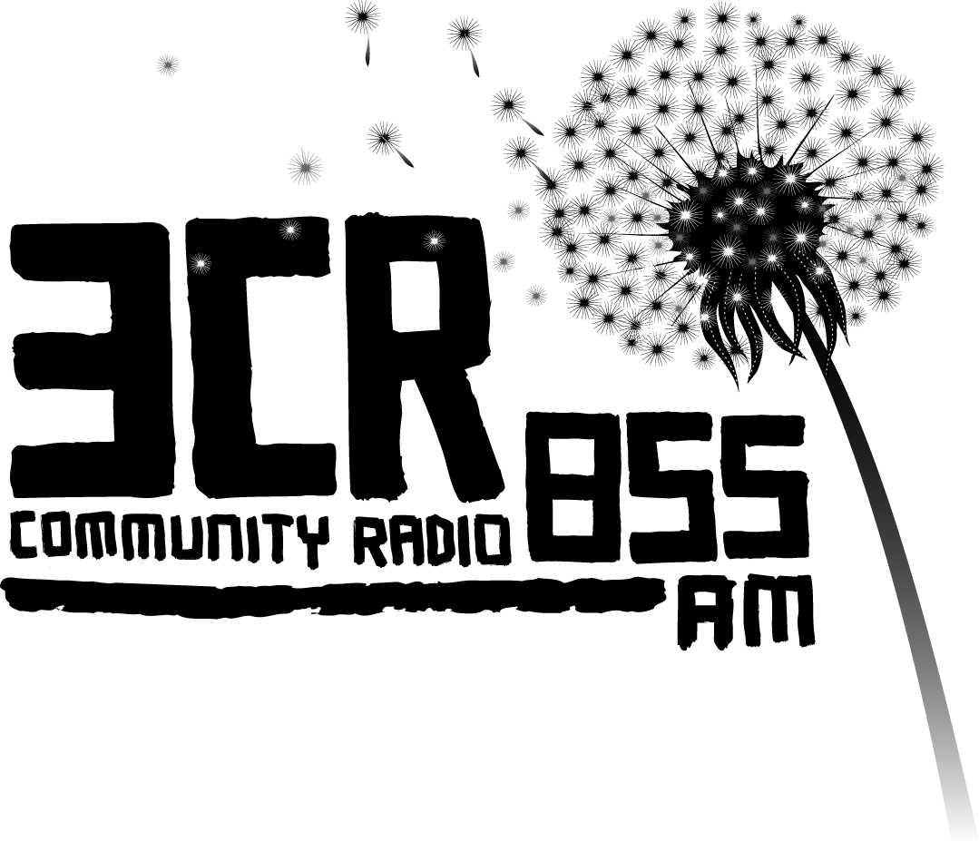
Beyond the Bars
Australia’s only live prison broadcasts
NAIDOC Week July 2-6, 2012
www.3cr.org.au/beyondthebars
Mon 2 July 11am-2pm – Dame Phyllis Frost Centre (Deer Park)
Tue 3 July 11am-2pm – Barwon Prison (Lara, near Geelong)
Wed 4 July 10am-12 – Fulham Corrections Centre (near Sale, Gippsland)
Wed 4 July 12-2pm – Loddon Prison (Castlemaine)
Thu 5 July 12-4pm – Port Phillip Prison (Laverton)
Fri 6 July 11am-2pm – Marngoneet Correction Centre (Lara, near Geelong)
Giving indigenous prisoners a voice Beyond the Bars

Beyond the Bars is a 3CR community project designed to give indigenous prisoners a voice. Encompassing music and spoken word workshops facilitated by indigenous presenters from Melbourne community stations 3CR and 3KnD, the project then culminates in six radio shows broadcast live from regional Victorian prisons during NAIDOC* Week 2-6 July, and can be heard on 3CR 855AM, 3CR Digital and streaming online, and simulcast on 3KnD 1503AM.

Beyond the Bars connects indigenous prisoners to the wider community and is a remarkable radio event that gives voice to the experience of indigenous inmates serving time in Victorian prisons.
For local singer/songwriter and one of the founders of the project, Kutcha Edwards, the broadcasts are an important way to give voice to indigenous prisoners. “Why is it that Australia’s indigenous peoples are the most imprisoned people per capita in the world? To hear the answers to that question, you need to tune in to Beyond the Bars.”
Beyond the Bars is Australia’s only live prison broadcast and this year is expanded to involve over 100 men, women and young people from the inside, sharing stories, songs, opinions and poems from within the Dame Phyllis Frost Centre, Barwon Prison, Fulham Correctional Centre, Marngoneet Correctional Centre, Loddon Prison, Parkville Youth Residential Centre and Port Phillip Prison.
The Beyond the Bars project has been running for over a decade, and has won several awards including the Human Rights and Equal Opportunity Radio Award in 2004 and the Community Broadcasting Association of Australia Contribution to Indigenous Broadcasting award in 2009.
Joh Kirby, Victoria Law Foundation Executive Director says, “Victoria Law Foundation is pleased to support Beyond the Bars 2012 during NAIDOC Week. Beyond the Bars gives indigenous inmates the opportunity to learn practical skills, and offers a unique forum for discussing and sharing their experiences of the law and the legal system with the broader indigenous community. We commend 3CR’s commitment to providing a voice to those most marginalised and under-represented in our community.”
Beyond the Bars receives financial support from the Community Broadcasting Foundation, the City of Melbourne, the Victoria Law Foundation and Corrections Victoria, Department of Justice.
For more information:
Lauren Zoric, Dog Day PR lauren@dogdayoz.com | 0405 793 722
Juliet Fox, 3CR Special Projects Coordinator, 9419 8377 / 0417 018 147

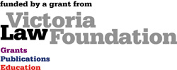
*National Aboriginal and Islander
Day Observance Committee


